FS40 Pivot Bracket

Version 3.0

Version 3.0 Goals
- Streamline the adapter to make the camera label visible
- Add a 3D Printed rotation pin to save the screw and make it faster to change camera.
- Create Left and right shoulder
- Add 3D extruded numbers to make them more visible

Camera drawings
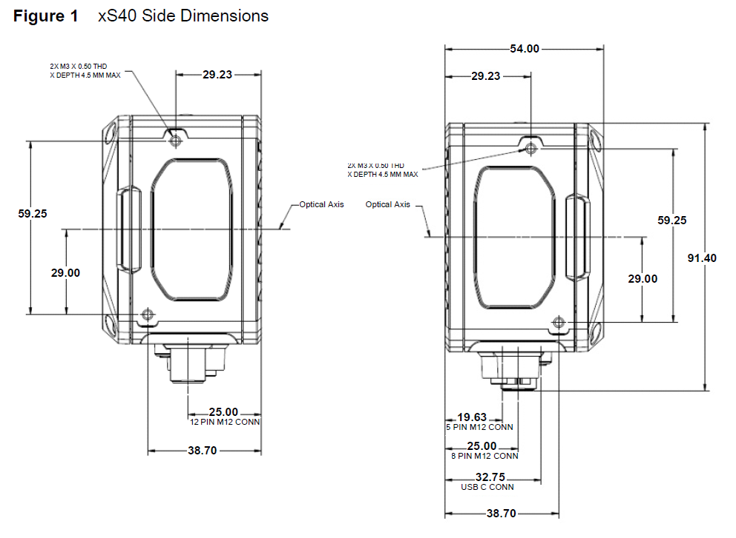

Adapter Plate
This plate is to connect to the camera side to the bracket creating a hinge centered around the camera optical axis

The bracket is symmetric and has twice the needed M3 holes just to use the same plate on both sides.

Base
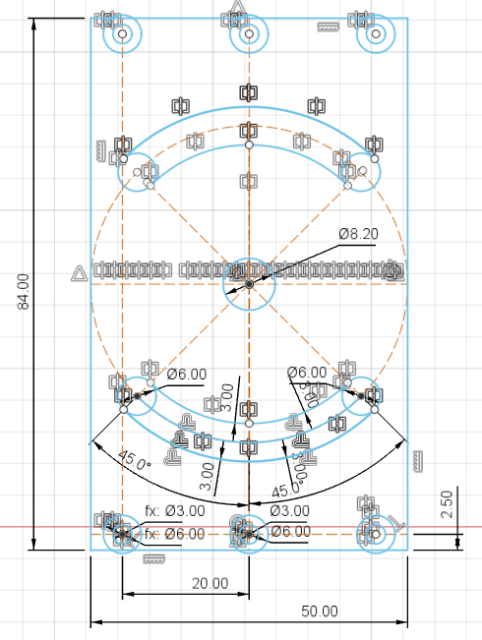

Final result
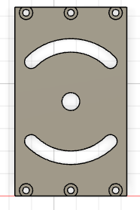

Shoulder
Version 3.0 create left / right shoulder and add extruded numbers to improve visibility
Version 2.0: larger rotation angle thanks to more locking holes. Now we can rotate from -45° to 120°

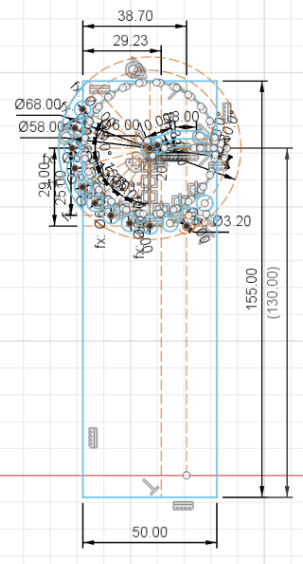

This is the detail about the locking holes
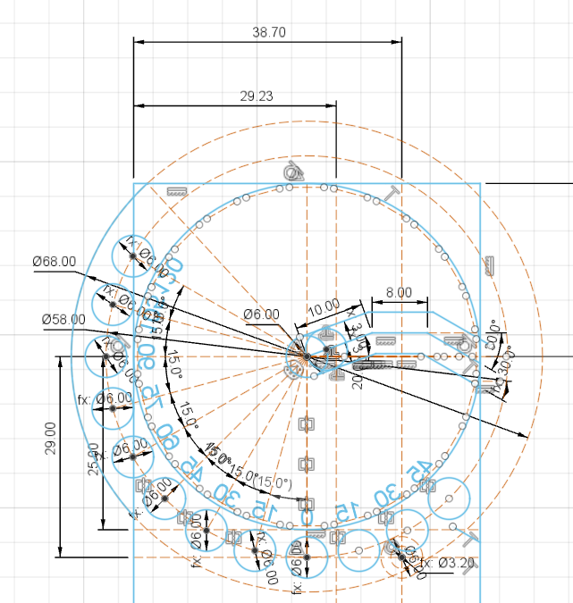

The pivot is made with 2 angles so the camera wouldn't fall down even with the brackets in vertical position. Two small teeth act as a stop block.
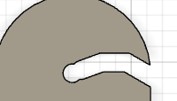 | 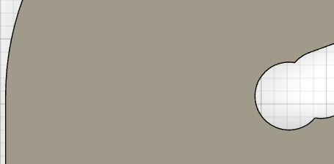

Embossed text indicate the rotation angle (but the result is not satisfactory)
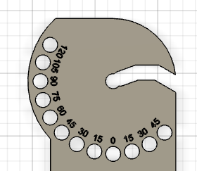 | 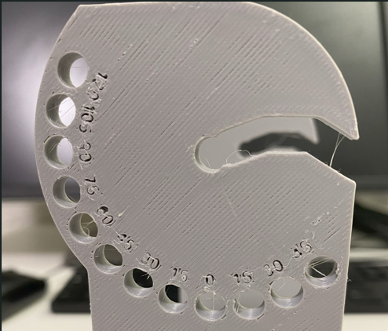
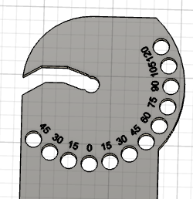 | 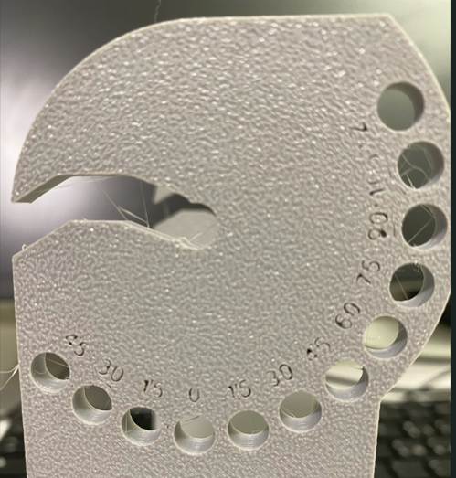

BOM
- M3 x 20 Screws: 6
- M3 x 10 Screws: 4
- M6 x 10 Screws: 4
- 6mm washers: 2
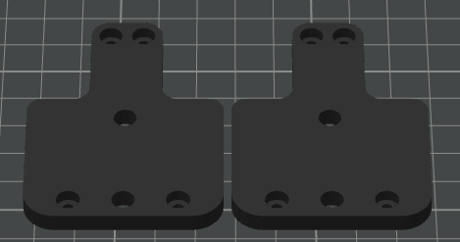

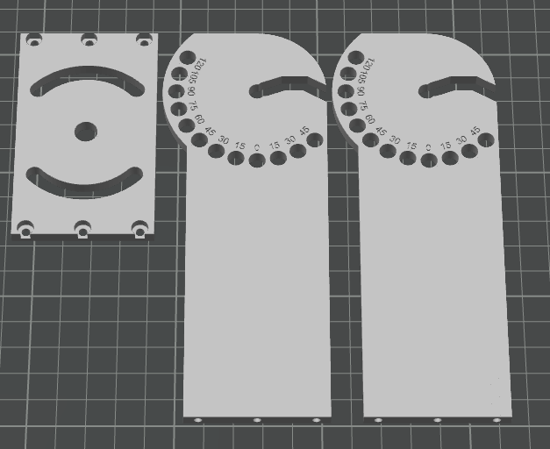

Final result
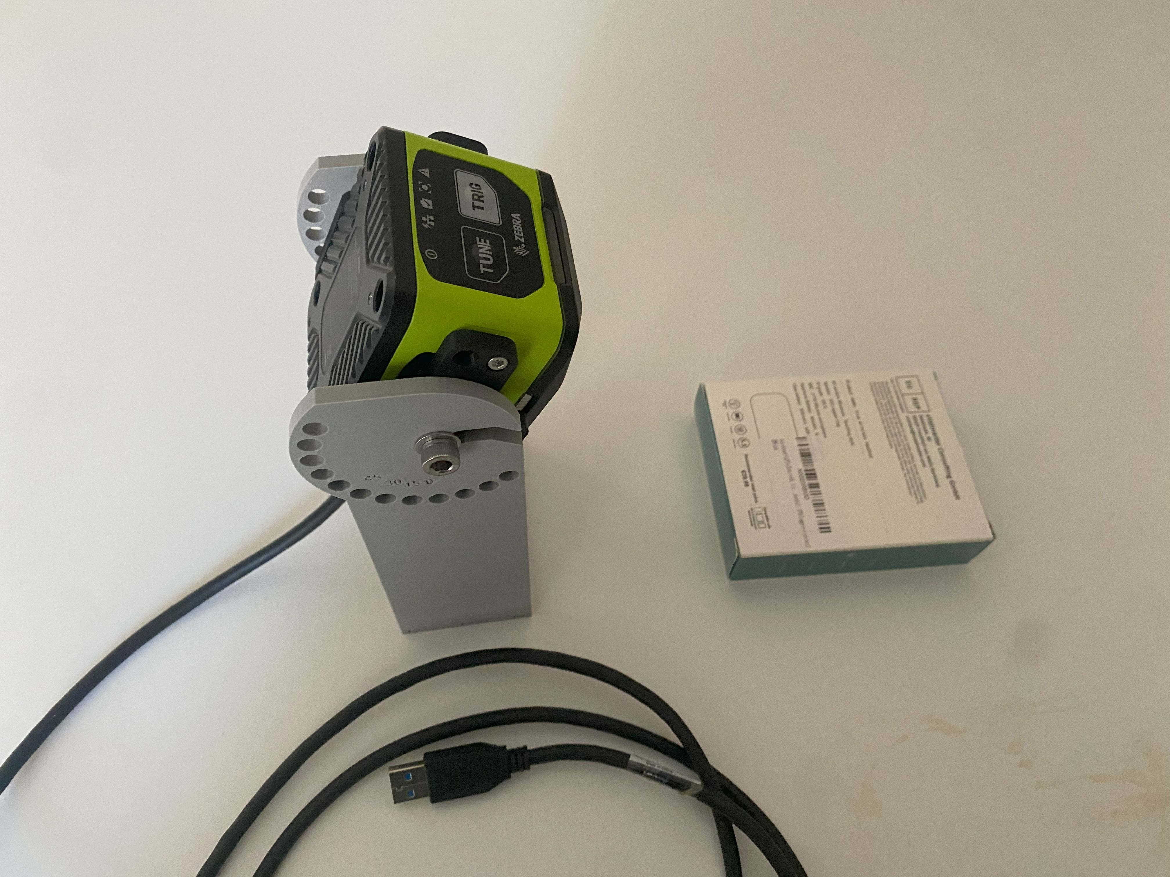

For the next iteration
Change the adapter shape to make the 360 Feedback LED visible | 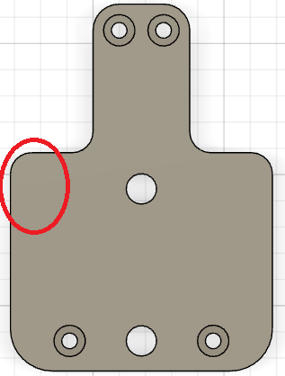
Rethink the central part of the adapter to make the label visible | 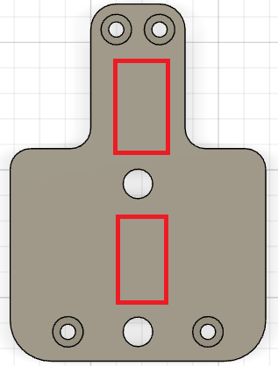
Reduce the size to align with the camera body | 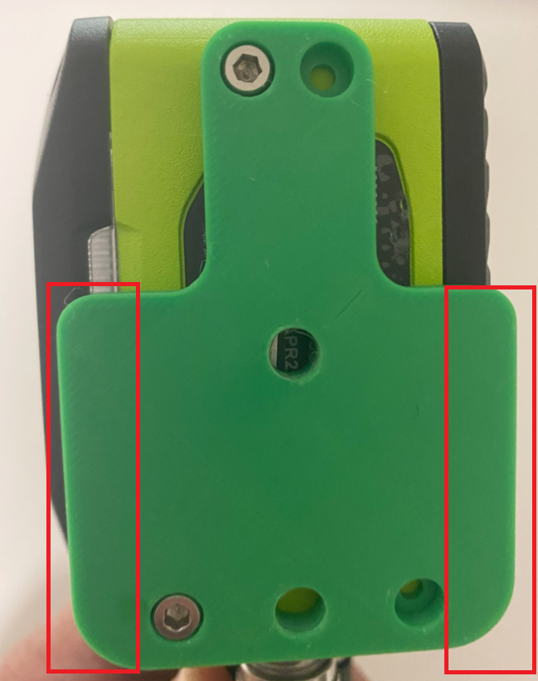

Starting V3
Making labels visible

